**Part 1**

* **Step 1**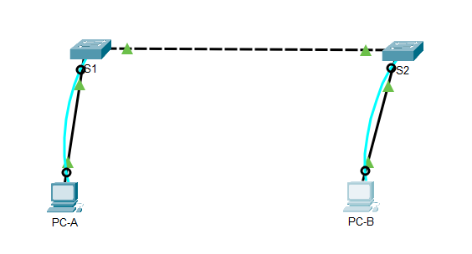
* **Step 2**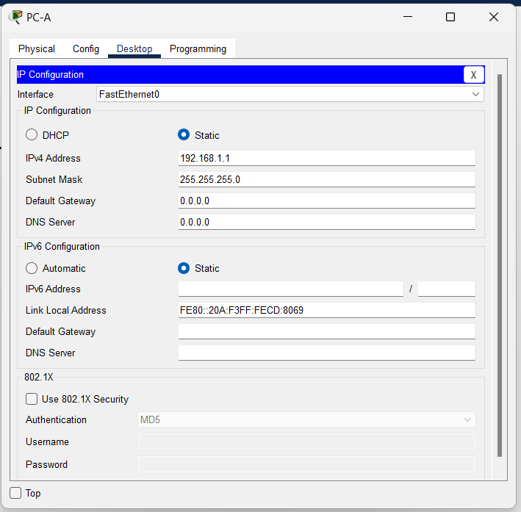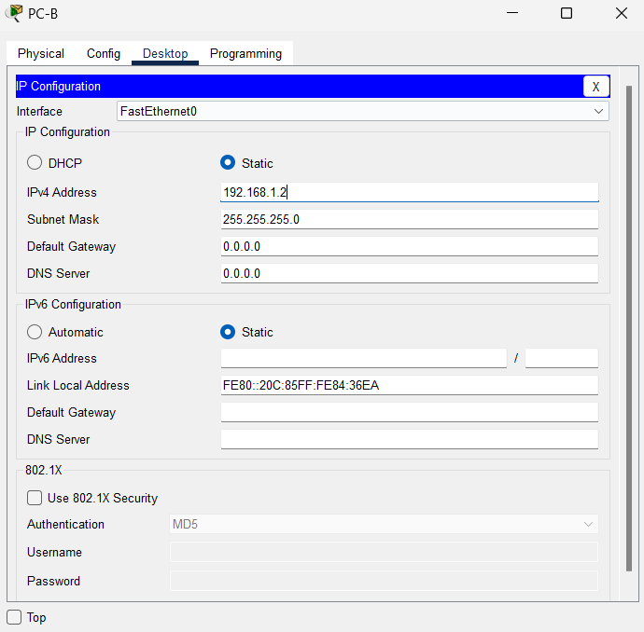
* **Step 4**

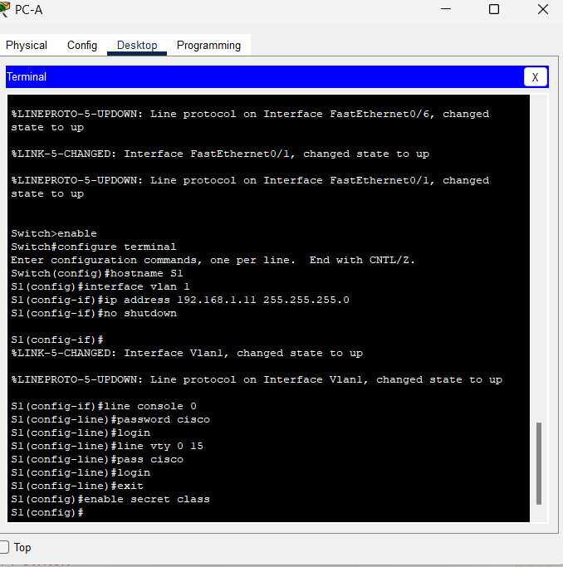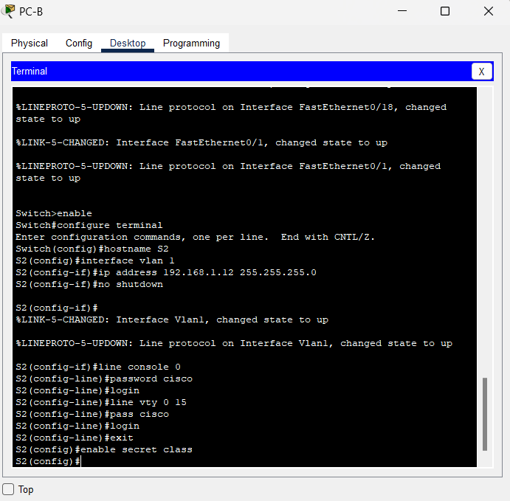

**Part 2**

* **Step 1**

**a, What are the Ethernet adapter physical addresses?**

* **PC-A MAC Address:** 00-0A-F3-CD-80-69
* **PC-B MAC Address:** 00-0C-85-84-36-EA

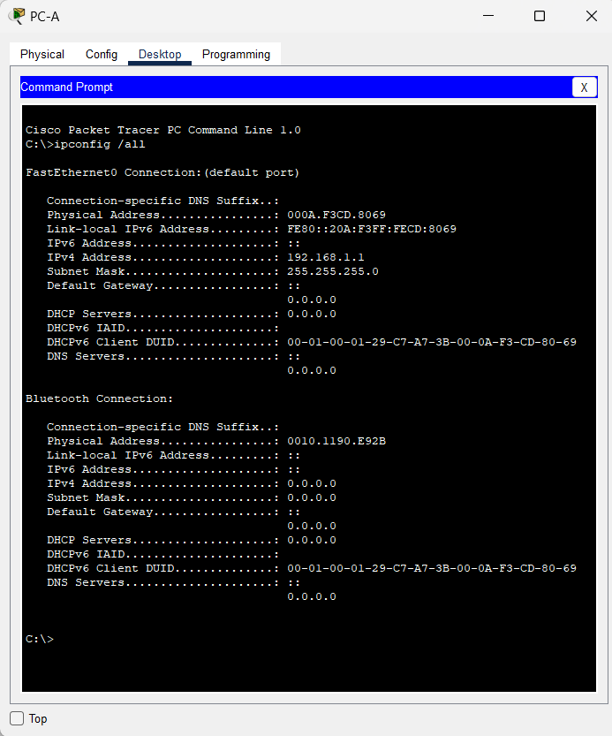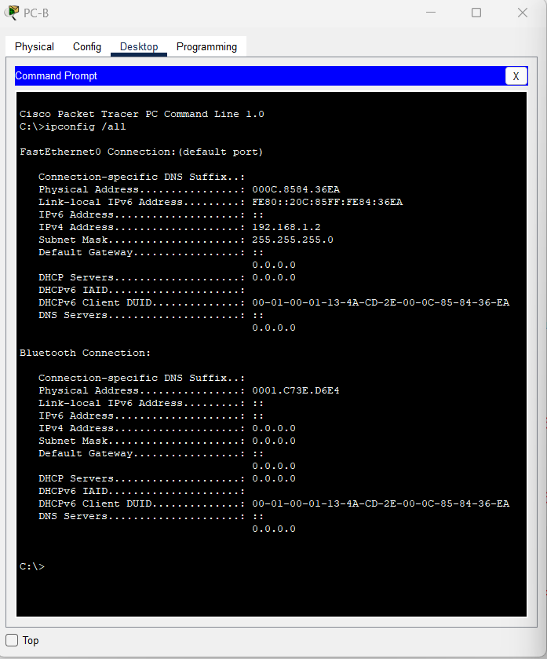

**b. Console into switch S1 and S2 and type the show interface F0/1 command on each switch.**

**On the second line of command output, what is the hardware addresses (or burned-in address [bia])?**

* **S1 Fast Ethernet 0/1 MAC Address:** 0090.0c94.1001
* **S2 Fast Ethernet 0/1 MAC Address:** 00d0.ba55.8b01

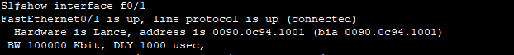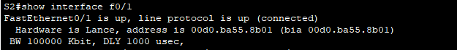

* **Step 2**

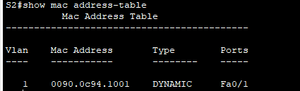

**Are there any MAC addresses recorded in the MAC address table?**

* There are only one MAC address

**What MAC addresses are recorded in the table? To which switch ports are they mapped and to which devices do they belong? Ignore MAC addresses that are mapped to the CPU.**

* The only MAC address recorded in the table is 0090.0c94.1001. It is mapped to the Fa0/1 port of the switch.

**If you had not previously recorded MAC addresses of network devices in Step 1, how could you tell which devices the MAC addresses belong to, using only the output from the show mac address-table command? Does it work in all scenarios?**

* It is not possible to determine which devices the MAC addresses belong to using only the output from the “show mac address-table” command.
* **Step 3**

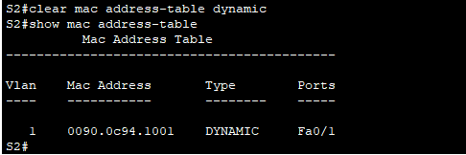

**Does the MAC address table have any addresses in it for VLAN 1? Are there other MAC addresses listed?**

* There are only the MAC address mapped to Fa0/1 port of the switch

**Wait 10 seconds, type the show mac address-table command, and press Enter. Are there new addresses in the MAC address table?**

* No
* **Step 4**

**a, **

* There are no device IP-to-MAC address pairs learned by ARP on PC-B

**b,** It’s all good

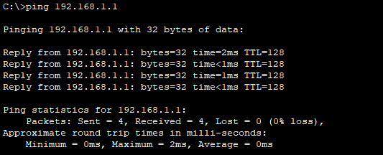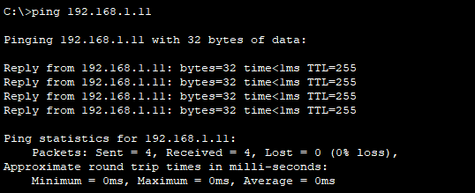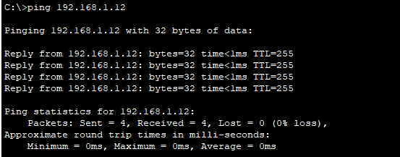

**c,**

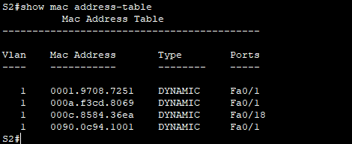

There are three MAC addresses added to the MAC address table.

* **0001.9708.7251** on **Fa0/1**
* **000a.f3cd.8069** on **Fa0/1**
* **000c.8584.36ea** on **Fa0/18**

**d,**

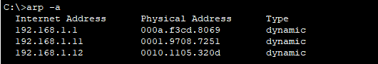

Yes, the PC-B ARP cache has additional entries for all network devices that were sent pings

**Reflection Question**

**On Ethernet networks, data is delivered to devices by their MAC addresses. For this to happen, switches and PCs dynamically build ARP caches and MAC address tables. With only a few computers on the network this process seems fairly easy. What might be some of the challenges on larger networks?**

* ARP broadcasts could cause broadcast storms. Because ARP and switch MAC tables do not authenticate or validate the IP addresses to MAC addresses it would be easy to spoof a device on the network.